ELEC 3EY4 – Lab 4

Objective 1

Question 1
Record the experiment results in a .csv file and plot them for your report. Explore how you can log the experiment with Realtime Data feature in the VESC Tool. Attach a screenshot of your plot tab in your report. Attach four graphs from your .csv file: one for RPM, one for q-axis current, one for voltage, and one for duty cycle. Explain how these variables change as the speed increases. What is the relationship between duty cycle, voltage, current, and speed?
- RPM
  - Rotations per minute directly correlate to the number of revolutions of the motor in a specific period. So, as the RPM increases, the motor spins
- Q-axis Current
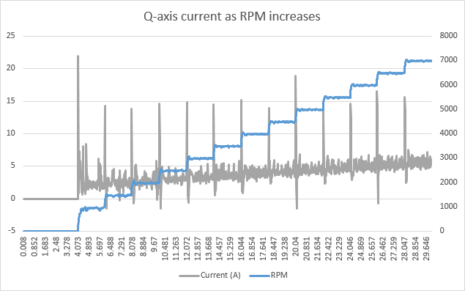

  - The current increases linearly with RPM, with a spike at the start of each RPM “step”. This spike is due to the torque increase and therefore current increase is required to accelerate the motor.
- Voltage
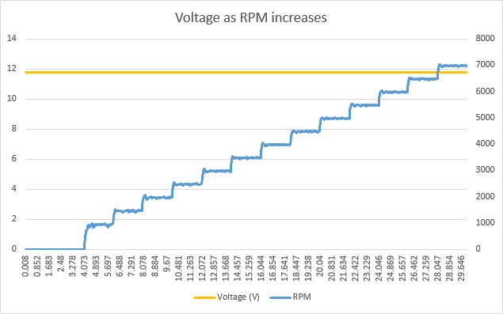
  - Voltage stays consistent regardless of RPM
- Duty cycle
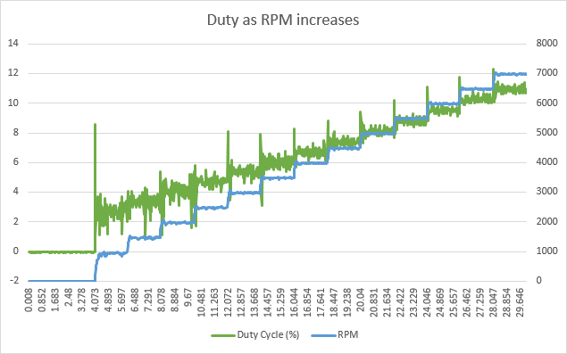
  - Duty cycle increases linearly with RPM, with a spike at the start of each RPM “step”.
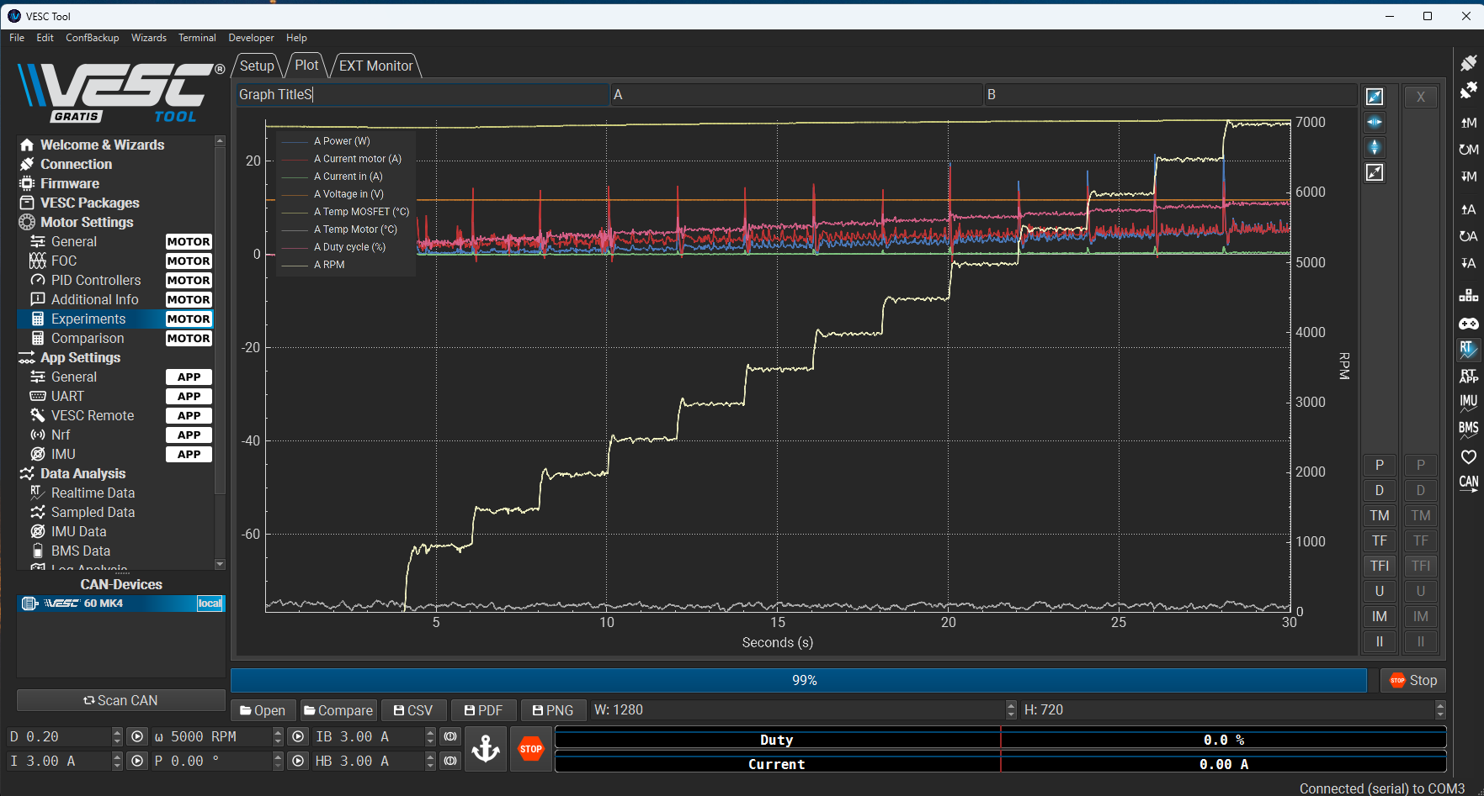

Question 2
Conduct a similar experiment and sweep the duty cycle command. The maximum duty cycle should be 0.2. Record the speed, q-axis current, voltage, and duty cycle. Plot the result. Compare the results with those from Question 1 when the speed command was swept. What is the difference in speed, current, and voltage response? Explain the reason why.

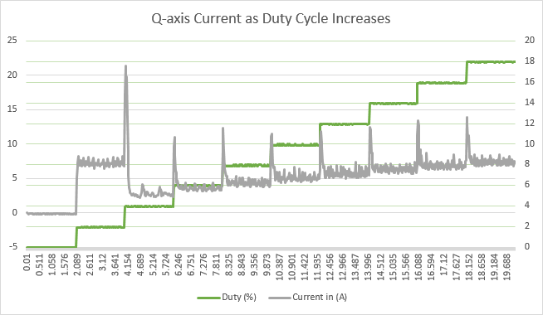

Q-axis current demonstrated a significant spike with each step increase for both speed and duty cycle control. More noise is displayed when using speed control. When using duty cycle control, the current also demonstrated smaller and controlled spikes, which remained positive.
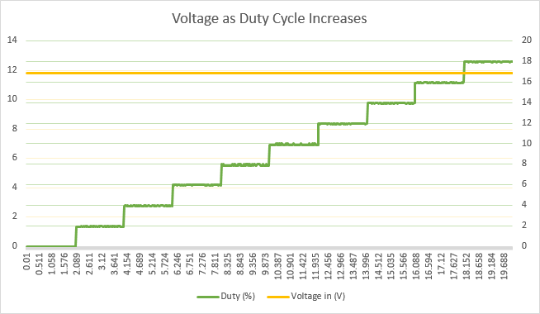
Voltage remained constant regardless of RPM or duty cycle increase.
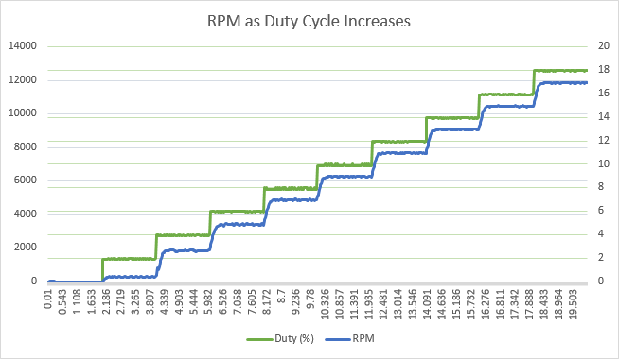

The RPM appears to have a smaller overshoot when using duty cycle control command. The duty cycle also demonstrates significantly less noise when using duty cycle control.

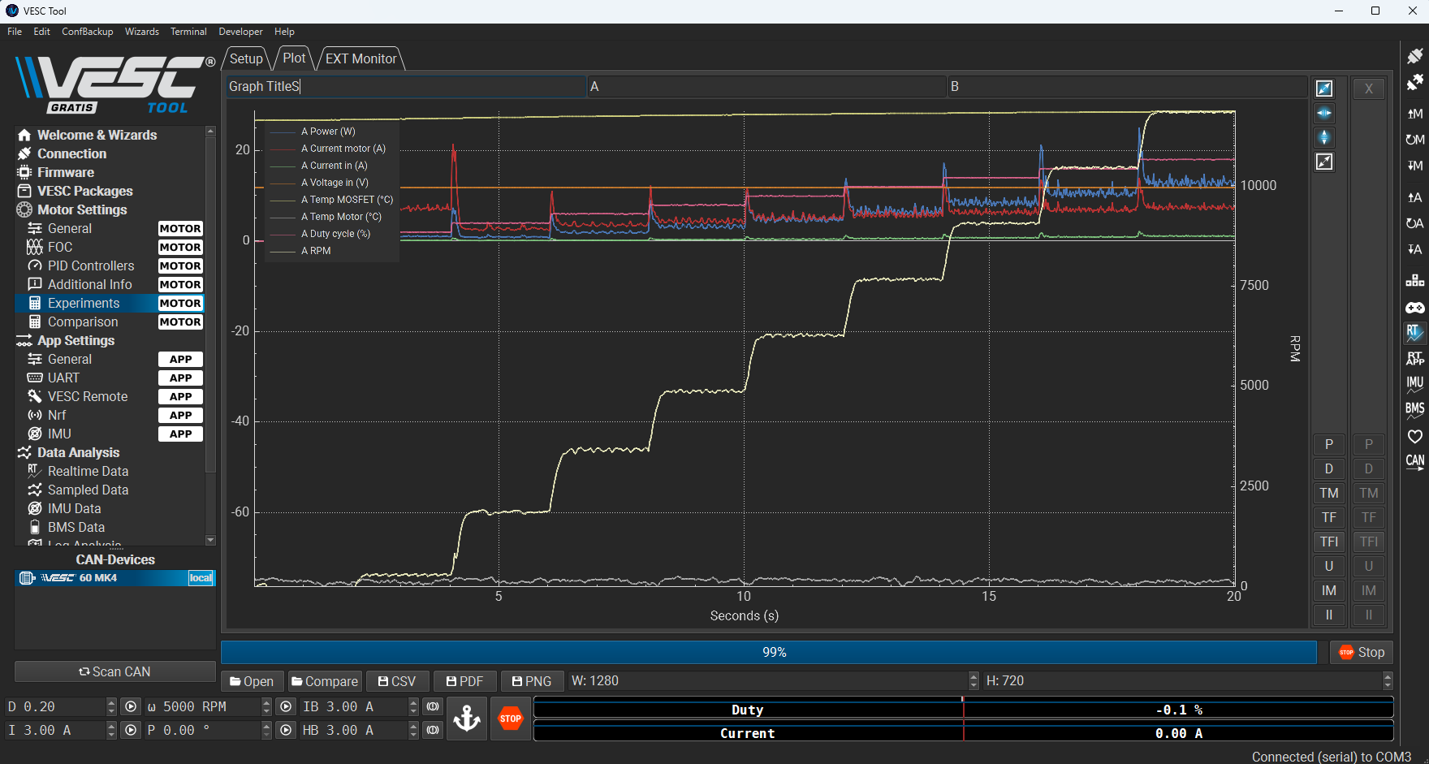
When changing the speed, the RPM had a much lower overshoot. There is less noise compared to when running the speed controller via the speed command was swept. Hence, the motor ran much smoother as a result.

Question 3
Conduct an experiment where you operate the motor at 0.2 duty cycle. When the motor speed reaches steady state, stop the motor operation using STOP button and record the real-time speed, current, and voltage waveforms. Then conduct the same experiment and, when stopping the motor, apply brake current command (IB) of 1A. Conduct the same experiments multiple times and increase the break current gradually up to 15A. Record the data. How does the speed response change? How does the q-axis current change? Explain the reason in the changes using the operating principles of the motor.

When using the stop button, the wheels came to a stop after a certain amount of time. However, when using the brakes button with a defined amount of brake current applied, it was noticeable that the wheels would come to a stop in less time relative to the stop command and come to a stop even faster when applying higher brake commands. This is a result of the brake command using negative current to counteract the kinetic energy that the motor already has, which allows the motor to come to rest faster. The stop command is equivalent to a brake current command of 0A. As the brake current command was set to increasing brake commands of 1A, 5A, 10A, and 15A, the motor would come to rest faster. This is visually depicted via the graphs below, as for each command, the sudden decreasing slope gets steeper and steeper as the brake current commands are higher. The q-axis current waveform during braking becomes negative, and its magnitude corresponds directly to the strength of the braking torque applied. This behavior is rooted in the operating principles of permanent magnet synchronous motors, where torque is proportional to q-axis current. By commanding a negative q-axis current, the motor drive essentially turns the machine into a generator, converting kinetic energy into electrical energy. The key observation is that increasing the brake current command increases the opposing electromagnetic torque, leading to a faster and more controlled stopping response.

STOP command:
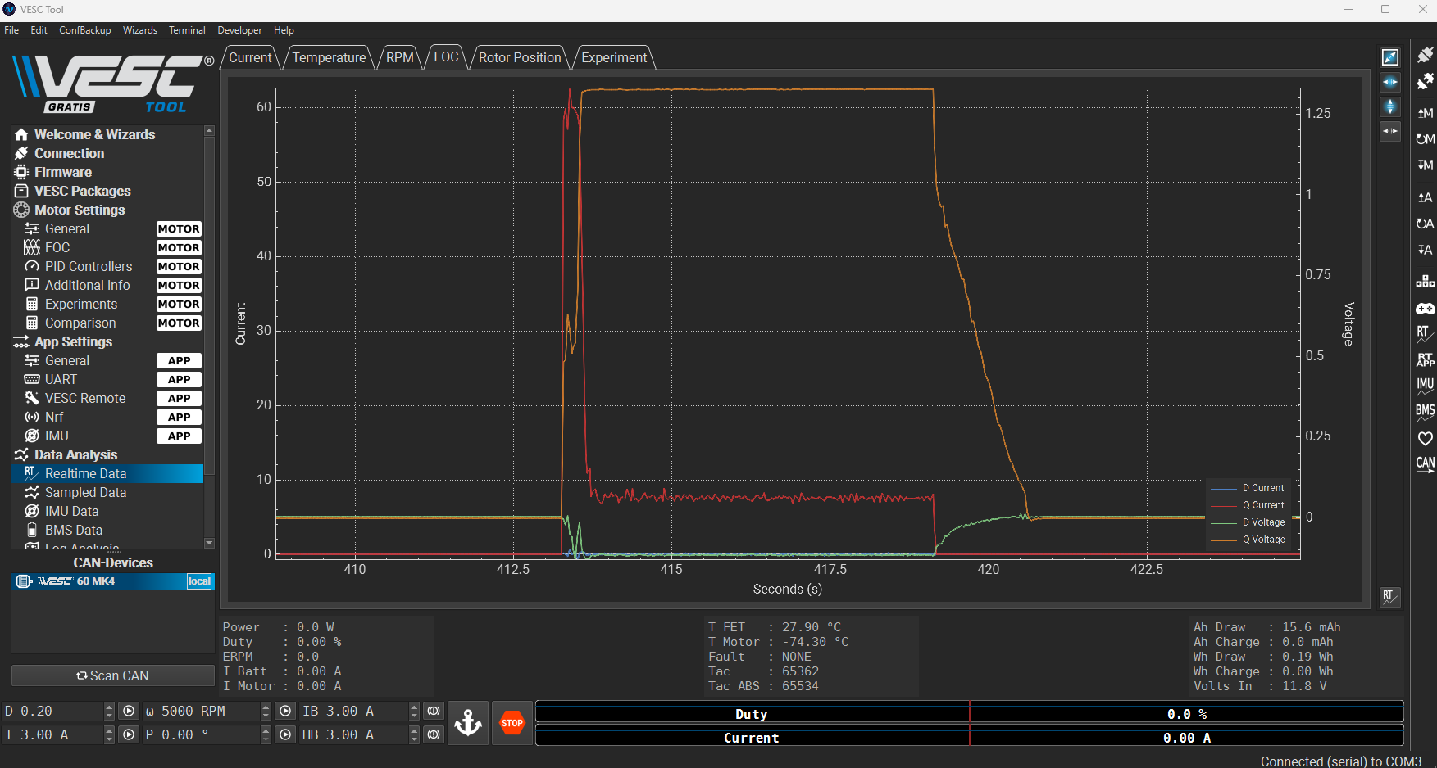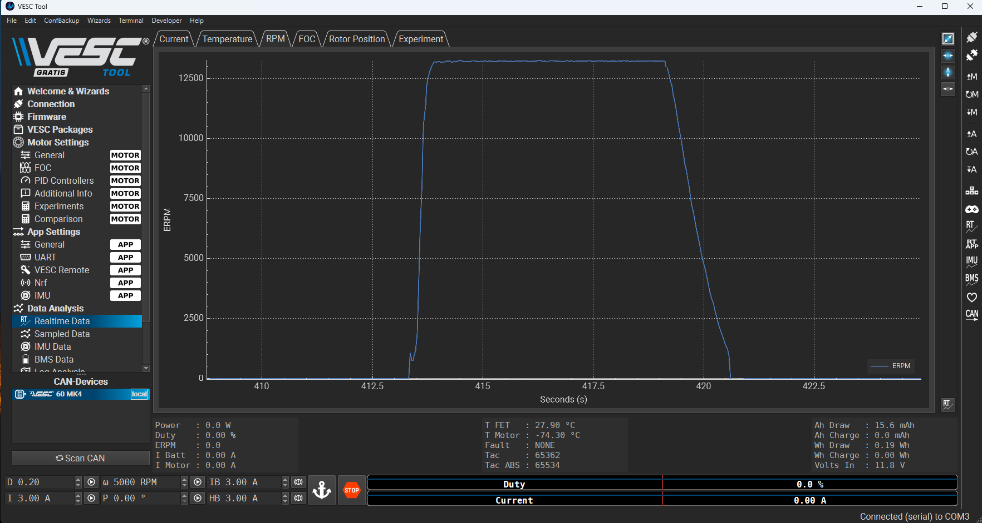
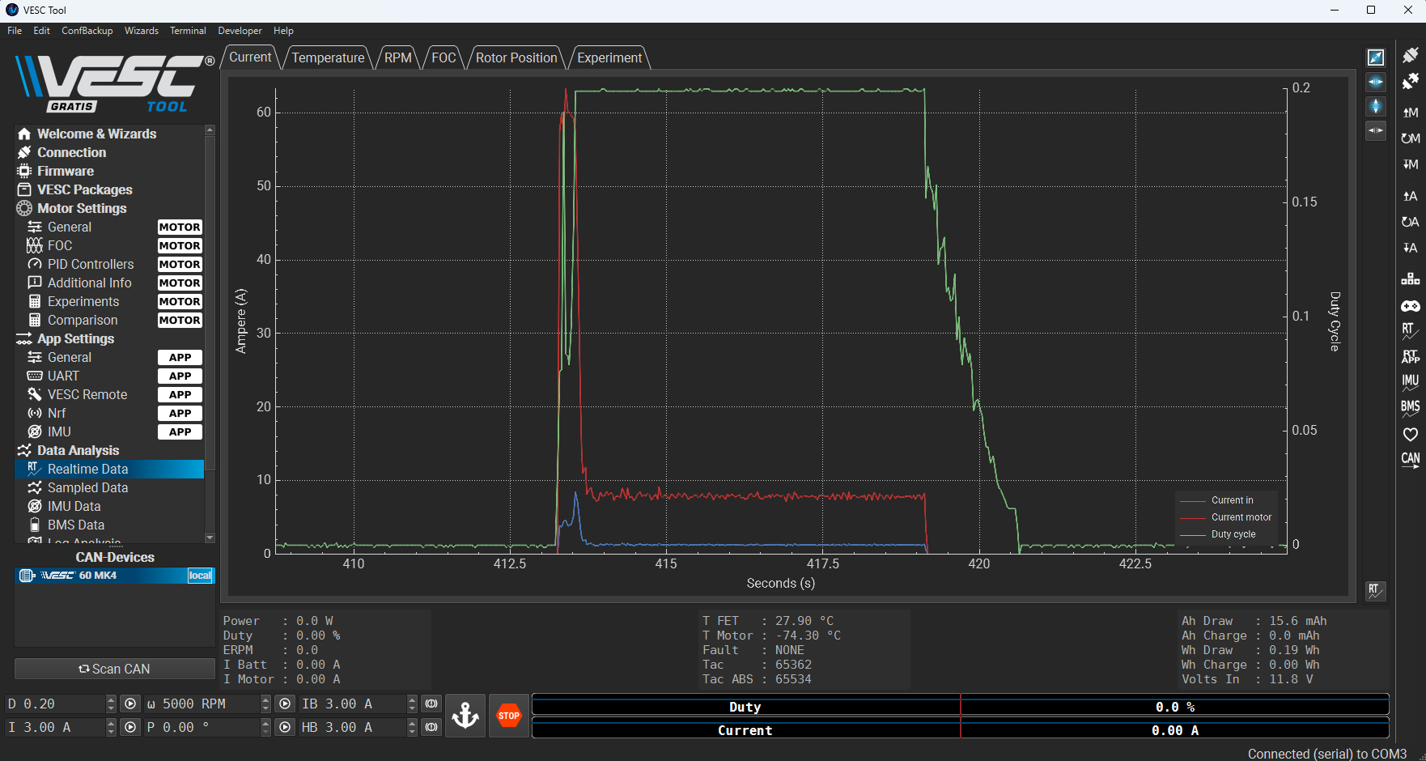

Brake Command:
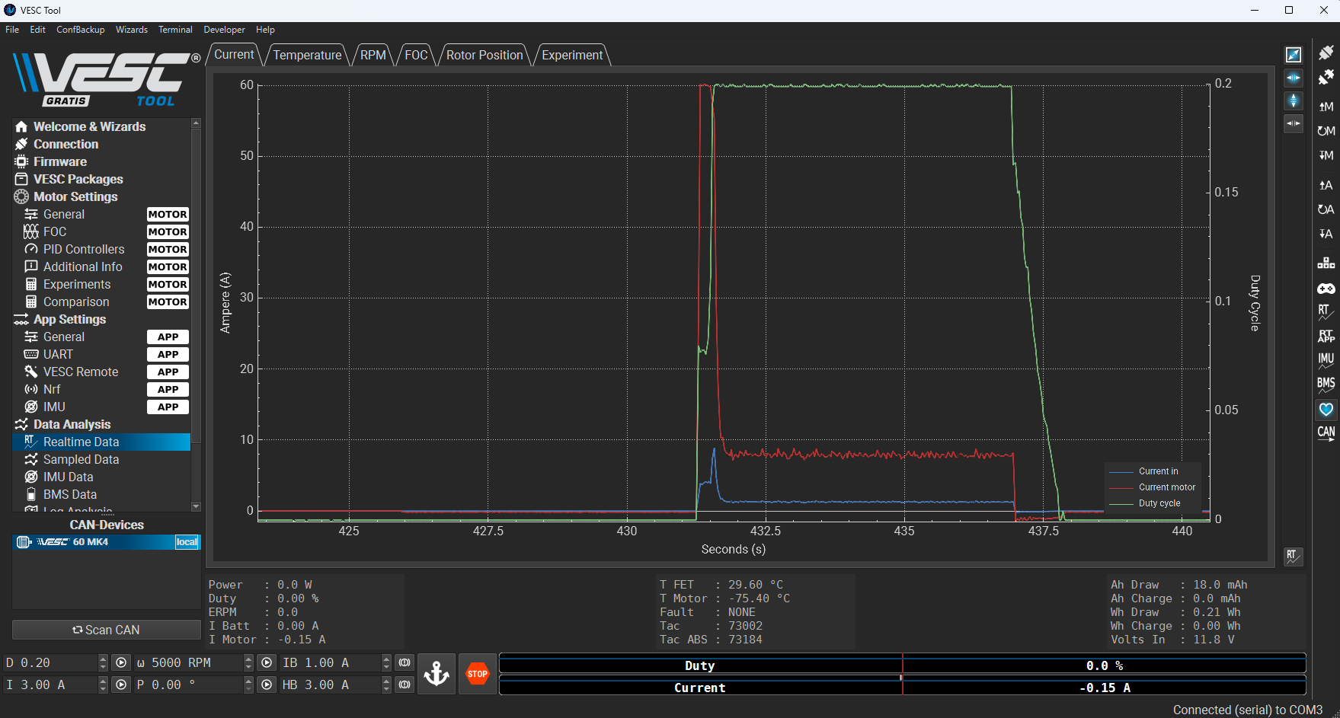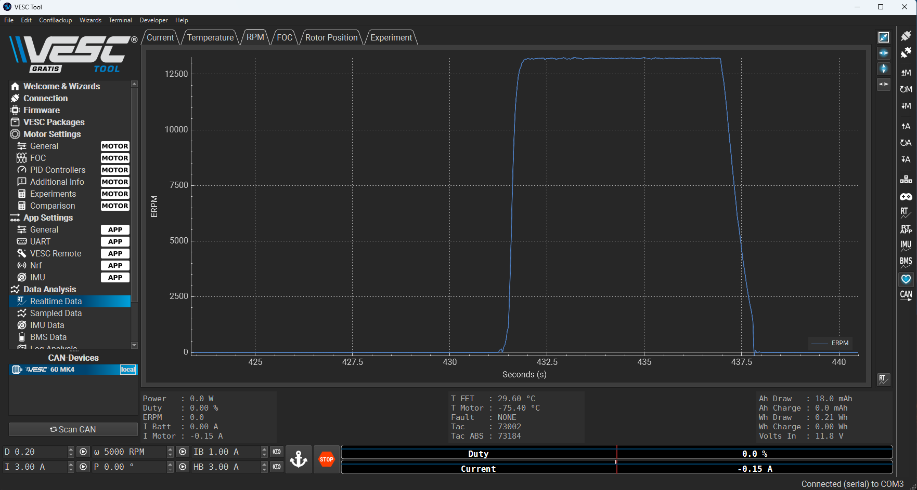

Question 4
Conduct an experiment where you apply a current command. Apply a current command of 8A. Note that you should not apply more than 8A to the motor at no load condition. Record the real-time speed, current, duty cycle, and voltage data. When the motor speed is at a steady state, reduce the current command to 4A. Record the same data. Note the speed at steady state. Explain how the speed, current, voltage, and duty cycle changed. Stop the motor. Apply a constant current command of 4A. Record the waveforms and explain the operation of the motor. What happened? Stop the motor. Apply a speed command for the speed you noted down earlier. Record the data and compare the results with those from the previous experiments. How did the motor operation change? Why?

Once the motor reached a steady state while using 8A and then switched to 4A, the motor speed decreased and reached a new steady state speed. However, when the motor was at rest from 0A and switched to 4A, the motor did not move, but slight sounds were heard from the motor. This is a result of the 4A on its own not being able to overcome the static friction / initial force that the internal magnets need to cause rotation within the motor. Furthermore, an induced current of 8A is enough to overcome the initial force / static friction needed to start the magnets rotation, so even though 4A is induced it is not enough on its own to cause initial rotation of the magnets, it is enough to keep the motor’s rotation going and overcome the kinetic friction to keep it at a reduced speed relative to the 8A current.

Objective 3

Question 5
Explore the Sampled Data feature in the VESC Tool. For constant speed operation in FOC mode, record the sampled phase current waveforms. Explore the FFT option in the VESC tool and apply it to the phase current measurements. Report the results by applying the speed command and then click on Sample Now button. Attach a screenshot of your FFT plot in your report.
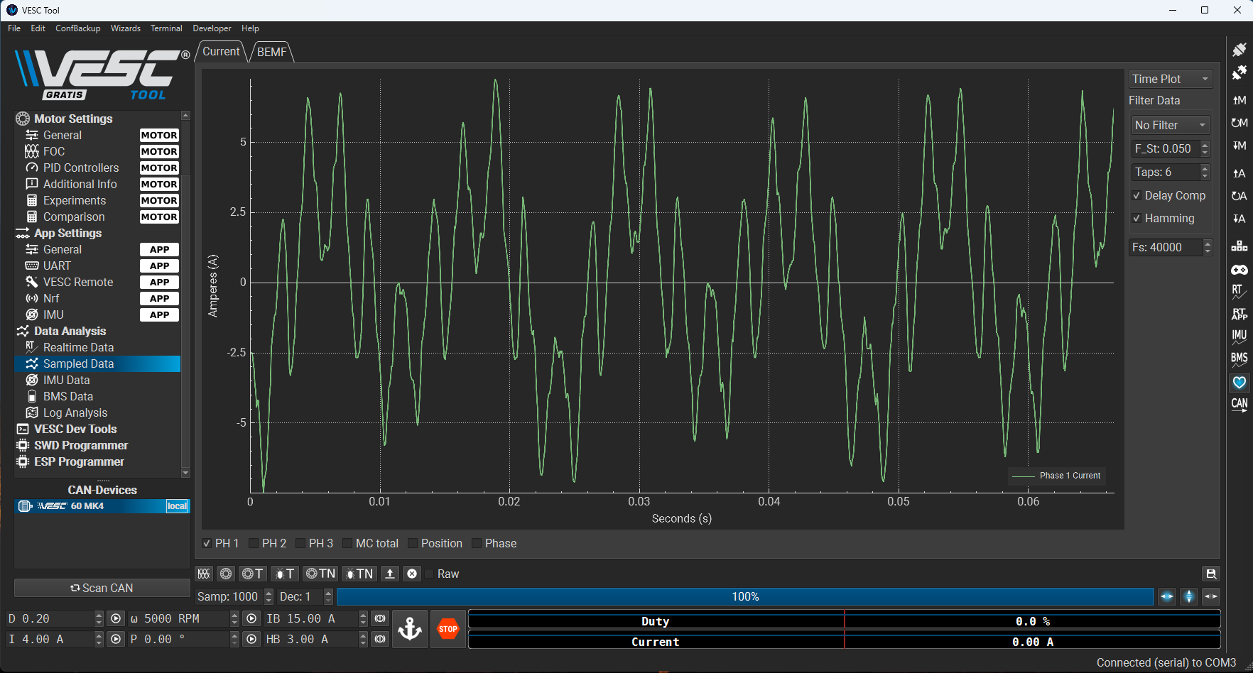
Figure: Transient analysis of phase current with constant speed command
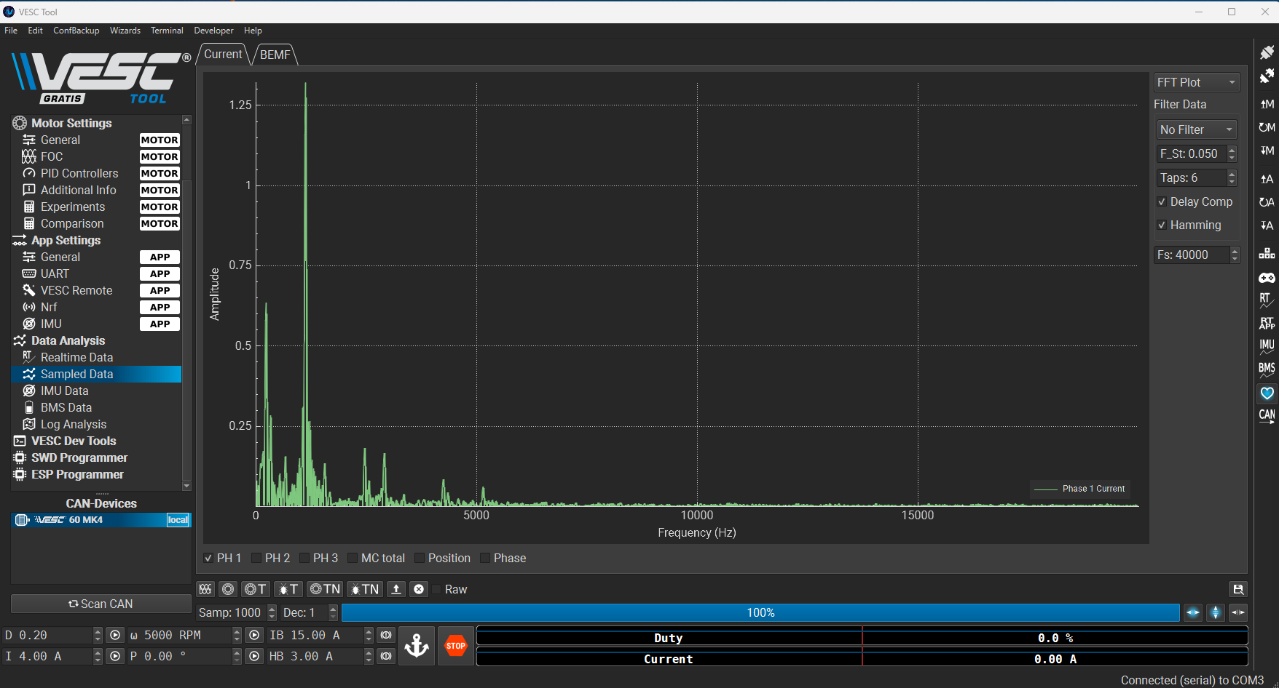
Figure: FFT of phase current with constant speed command

Question 6
What is an FFT plot? Why is an FFT plot applied to the phase current measurements important when analyzing the behavior of a motor?
- The Fast Fourier Transform plot allows us to visualize the signal in the frequency domain instead of time. Through the FFT plot, we can visualize what frequency components are present in the signal, and what magnitude they have. We can see from question 5 for example, the main frequencies of the signal are primarily between 0 and 2500 Hz, with a dominant frequency around 1250 Hz with a large magnitude.
- The FFT of the signal can help us visualize how smooth the motor is running at via its phase current, as specific harmonics and/or lots of noise can impact how the motor is rotating as a whole
- When analyzing the behaviour of the motor, the phase currents must be in phase with the voltages to ensure maximum power possible. The phase of the currents must also be offset by a certain amount from the motor’s magnets to ensure that the currents can lead ahead so the magnets can lag behind and “chase” the current creating the rotational movement allowing for correct motor behaviour.

Question 7
For 2500 rpm, 5000 rpm, 7500 rpm, record the motor phase currents and phase backemfs using the Sampled Data feature. For each speed and each phase, plot the phase current and phase back-emf on the same graph. You might need to adjust the scale of the current and voltage to show them in the same graph. What is the phase shift between the phase current and phase back-emf at each speed and for each phase? How does the frequency of the phase current and phase back-emf change with speed? Explain the reasons using the electric motor fundamentals.
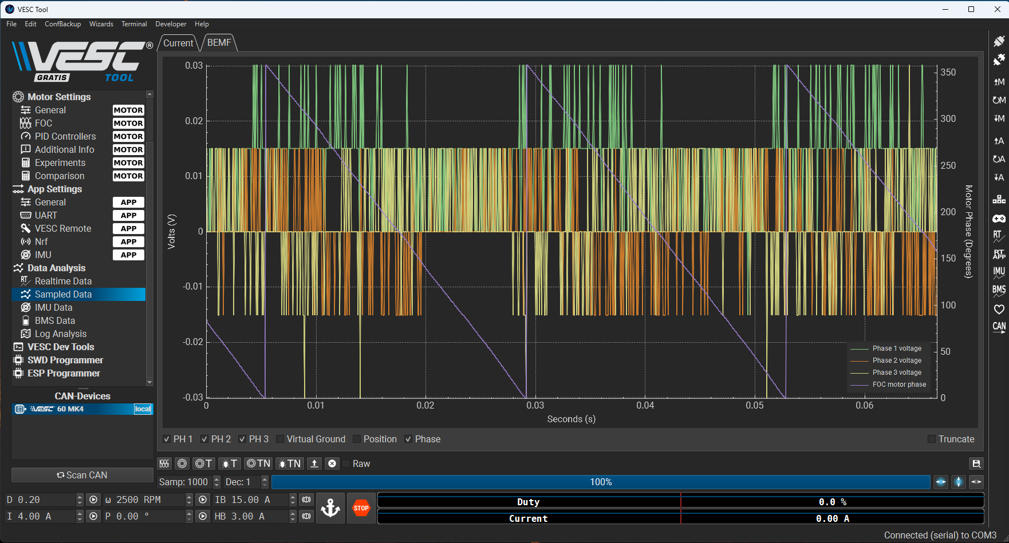
Figure: Sampled data feature measuring motor phase currents
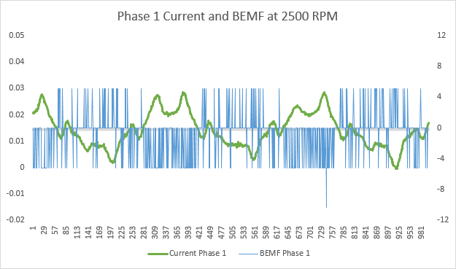 | 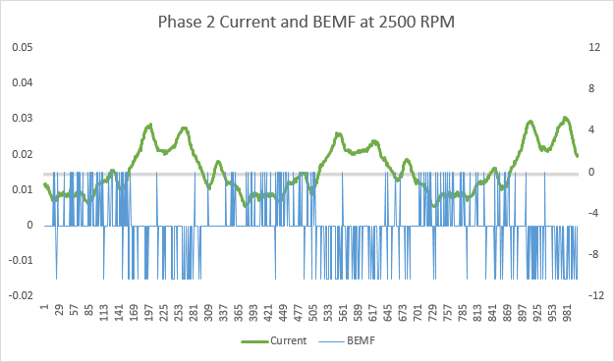 | 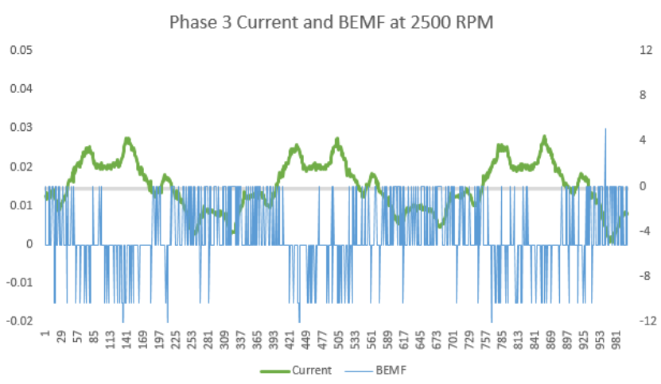
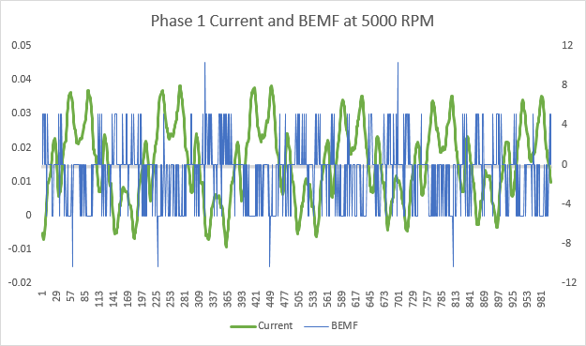 | 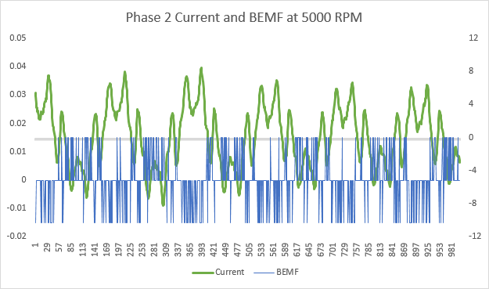 | 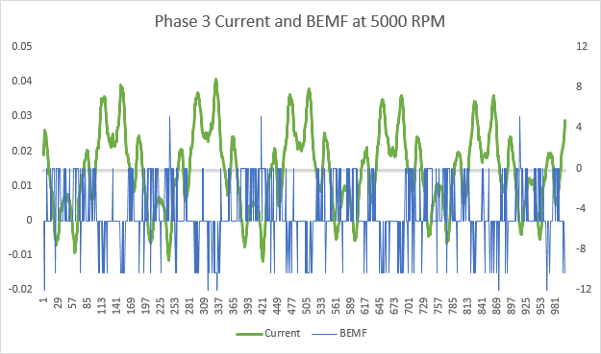
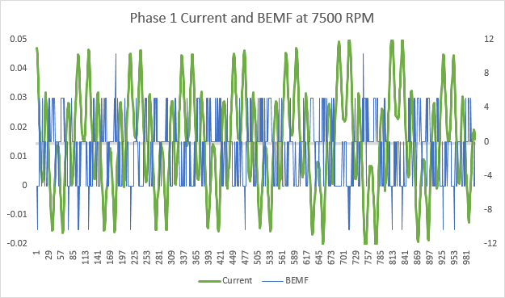 | 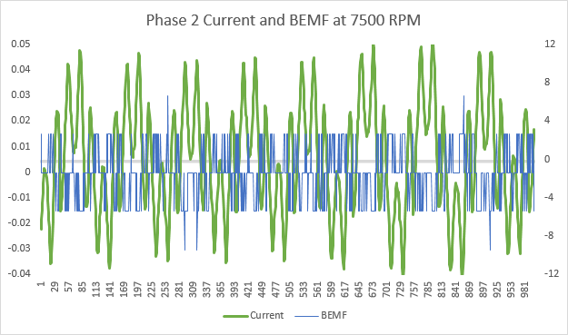 | 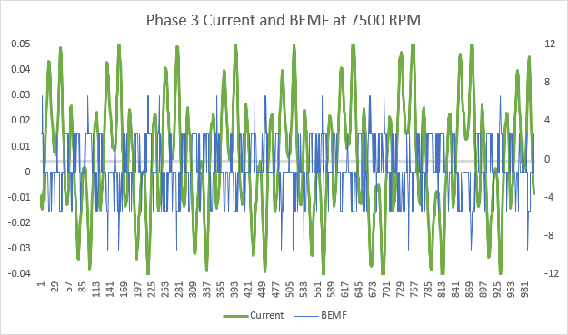

- We can see that there is a phase shift of approximately 180 degrees between the phase current and back EMF for each phase, regardless of the RPM speed.
- However, in order for proper motor behaviour and maximum power, the currents and back EMF should be in phase, but as depicted from the graph, there is a 180 degree shift instead of no shift at all. This may be as a result of the phase current measurements above are the actual measured in winding A, B, or C while the q-axis currents are mathematically transformed quantites in the rotating dq reference frame.
- As we increase the RPM, the frequency of the phase current and back EMF increase as well
  - If the rotor magnets rotate faster, the flux from the magnets increases which then increases frequency ($ω = \frac{dϕ}{dt}$)
  - The faster time-changing flux from the magnets induce a higher frequency and larger magnitude voltage across the windings (back EMF)
  - This then generates the electrical power and torque needed for the motor

